- Introduction

Stocks Return Prediction Using Deep Learning

Ruhul Gupta *  Stanford University  rahulguo@stanford.edu | Pan He (Gabby) *  Stanford University  panhe@stanford.edu | Tesa Ho *  Stanford University  tesaho@stanford.edu

Stock market, now 25 Trillion, is one pivotal player in US economy. Predicting stock returns, using either company’s financials or quantitative factors, has been considerd one of the most challenging and rewarding work, due to the noise and volatile features of the time series [1]. In the past decades, both academia and industries have done extensive studies using machine-learning models to predict financial time series, such as support vector machine [2], and neural network [3]. In this project, we would like to attempt to predict stocks returns with cutting-edge technology in deep learning.

Several papers have attempted to predict time series with recurrent neural networks (RNNs), in particular Long Short-Term Memory (LSTM) [4], while application of convolutional neural networks (CNN) to time series prediction is a relatively new area [5]. Persio and Honchar laid the framework for comparing different deep neural network models for stock prediction [6]. The authors tested a Multi-layer Perceptron (MLP), CNN and LSTM separately on the S&P 500 index prices. The results indicated that the CNN was able to model the financial time series better than the other models.

Problem Statement
Inspired by these works, we would like to expand the stock prediction scope to individual stock, and propose to use following deep learning model architectures for daily stock return prediction [7].
• LSTM
• CNN
• CNN + LSTM

Our investable universe is S&P500 – the top 500 US companies based on market cap – a good representation of the US stock market. We will collect daily stock data of S&P500 constituents for the past 10 years from intrinio.com and Bloomberg terminal. Concretely, the time series data for each stock includes:
• Daily open/close, high/low price (ohlc price)
• Trading volume
• Market cap
• Earnings
• Sector/industry classification

The output of the model could be two types: buy/sell signal for each stock; or alpha (ranking) of the stocks in the universe. In either way, we will construct a new portfolio and compare it against benchmark with following financial metrics:
• Absolute/relative returns
• Tracking errors
• Sharpe/Sortino ratios
• Maximum drawdown
• Profit and loss distribution

In addition, we will evaluate the prediction via statistical evaluation methods such as classification accuracy, area under curve, r-squared and mean squared error.

There are several potential improvement area from previous works. First, the input from previous work only considered technical features, which is price and volume. We would like to include some fundamental features, such as earnings, into our model. These type of features are relevant to indicate future stock price, and are often keys to traditional fundamental equity research. Second, previous works are usually focus on a singular time series of return, such as S&P500, and fail to take into account correlations among each stock constituent. We would like to predict single stock price, but would also like to use multiple time series of stock price to consider correlation among them, classified either by sector or by market cap. From economic standpoint, stocks in same sector or industry may encounter similar regulation, industrial headwind/tailwind, and technical disruption.

In addition, we will use reinforcement-learning algorithm to construct a new portfolio based on the model output, and test it against benchmark.

Technical Approach
We would like to adopt architecture from previous time-series prediction [7] as our start point. Specifically, for CNN model, we use Conv -> ReLU -> dropout (not sure why we do dropout here? what is our filter size?) For LSTM model, we use LSTM (100 neurons) -> dense (100 layers) -> dense (100 layers) -> ReLU -> dropout. (what is dense? What good about this architechture?)
Both models would use ADAM optimization as starting point.

Data Gathering
Data gathering has been an issue, as none of us has personal subscription to traditional data vendor such as Compustat/Factset/IBES. We did manage to get daily open/close, high/low price and volume data from intrinio.com for past 10 years, and a list of current S&P500 constituents. We are working on to get S&P 500 historical constituents, which rebalances every quarter, as well as fundamental data. The data we have gathered should give us a sufficient start.
For 10 years of daily data, we use 7 years of data as training set, 2 years of data as validation set, and the rest 1 year as test set. We use rolling window of 1-year data to predict the next daily price/return. We may also try expanding window if time permits.

Input
Data preprocessing is required to transfer the 1-dimensional time series into multiple channels. For each stock, height is 1 and width is 365 (one year of data). Channel is 5, including four features from ohlc price, and one feature from trading volume. Later we will add another 2 channels with earnings and market cap.

Output
We mentioned that the output of the model could be two types: buy/sell signal for each stock; or alpha (ranking) of the stocks in the universe. For this round, we would like to do buy/sell signal, so that each stock could be trained individually. There are two types of buy/sell signal – absolute or relative. We define an absolute buy as a stock’s predicted return is positive or zero; an absolute sell as a stock’s predicted return negative; a relative buy as a stock’s predicted return is higher than or equal to S&P 500’s predicted return; a relative sell as a stock’s predicted return lower than S&P500’s predicted return. Specifically buy is 1 and sell is 0.
The definition of return is (predicted price – previous price) / previous price.

Loss function
We use l² loss function for our model because of its simplicity. We may also try softmax loss function for further experiment, but we do not have a deep theory behind the choice [5].

Reinforcement-learning Algorithm
Add more

Preliminary Results

Add more
Explain charts
Explain what has been failed?

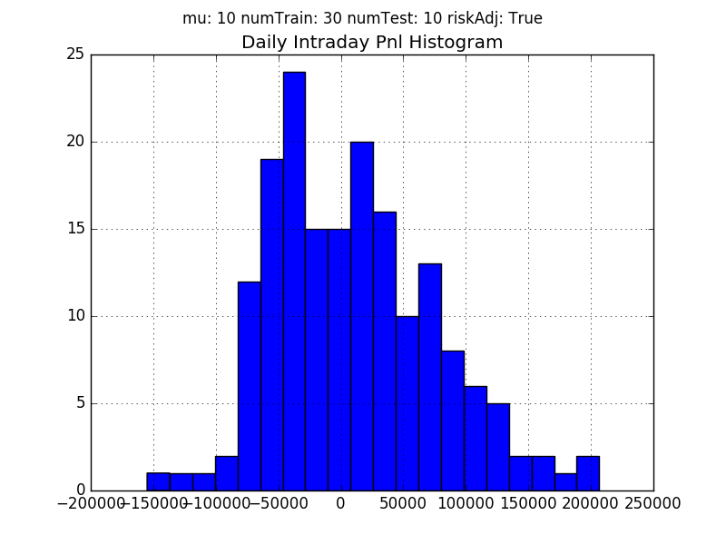

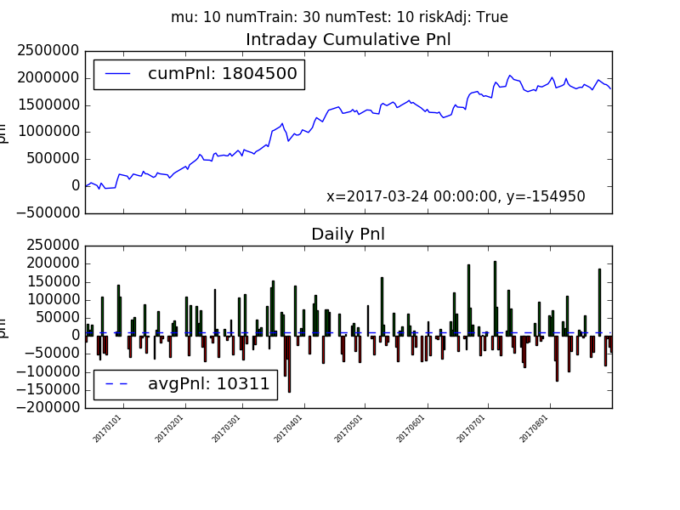

References
- Bao. W, Yue. J, Rao. Y PLoS ONE 12(7): e0180944. https://doi.org/10.1371/journal.pone.0180944.

- Huang. W, Nakamori. Y, Wang. SY Computers & Operations Research. 2005; 32(10):2513–22.

- Moghaddam. A, Moghaddam. M, Esfandyarica. M, Journal of Economics, Finance and Administrative Science (2016). https://doi.org/10.1016/j.jefas.2016.07.002.

- Shi. XJ et al. Twenty-Ninth Annual Conference on Neural Information Processing Systems (NIPS), 2015.

- Siripurapu. A, Stanford CS231n (2015), http://cs231n.stanford.edu/reports/2015/pdfs/ashwin_final_paper.pdf.

- Di Persio. L, Honchar. O. Artificial neural networks architectures for stock price prediction: Comparisons and applications. (2016) 10. 403-413.

- Grob. W et al. ESANN 2017 proceedings, European Symposium on Artificial Neural Networks, Computational Intelligence and Machine Learning. Bruges (Belgium), 26-28 April 2017, i6doc.com publ

Figure 1: Example of a figure with caption. Captions are set in roman, 9 point. Use a Drawing area to make space for figures.

* co-first authors, alphabetical order

